SITC OF X-FORCE HISTORIAN AND DASHBOARD DEVELOPMENT
SOHAR STEEL OMAN
Project | SITC of X-Force Historian and Dashboard Development for Sohar Steel Oman
Prepared By | Mahesh Udar
Document Type | SMS Plant Process Time Event
Handover Date
Handover To
Document Version | 1.0

Declaration
This Project Handover Document is intended only for personnel who already have a working knowledge of the X-Studio framework and related technical concepts.
The reader is expected to have prior knowledge of the X-Studio Event Framework, Workflows, Asset Structure, Database Structure, SQL Logic, and Stored Procedures. This document is prepared as a project-specific technical handover and reference document and is not intended to provide basic or introductory training on these concepts.
The document focuses on the project-specific implementation, configurations, process flows, database objects, SQL logic, workflows, and related technical details required for Project Support, Maintenance, Troubleshooting, and Further Development.
Therefore, readers should have sufficient prior knowledge of X-Studio and the above-mentioned technical areas to effectively understand and utilize the information provided in this document.

SMS Plant Process Time - Process State Tracking

1. Overview
This section describes the event configuration used for tracking the overall plant process timing across EAF, LRF, and CCM. The SMS_Plant_Process_Time event configures a single, ordered chain of process states - from EAF roof opening through CCM billet production and turret control - used to time the process and, for the later states, to trigger downstream heat-ID resolution and data updates via workflow.
States 1 through 10 have WorkFlow disabled. These states do not need a stored-procedure action to resolve which heat they belong to: they simply read the live current value of the heat-number tag EAF_HEAT_NUMBER_PRM at the moment the state condition is evaluated, and use that live value directly as the heat reference. From state 11 onward, WorkFlow is enabled, because by that point CCM is casting a heat that is no longer the live EAF heat, so the stored-procedure action in section 4 is needed to resolve the correct historical heat ID.

2. Event Configuration

2.1 Event Entity
The main event data is stored in the SMS_Plant_Process_EventTime entity.
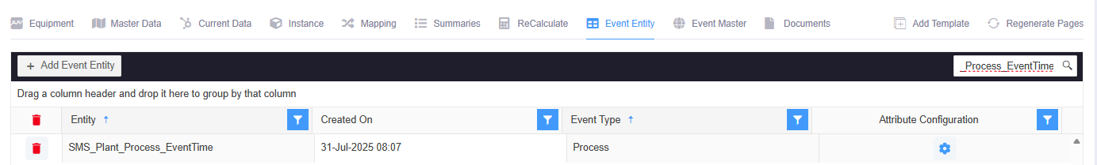

2.2 Event Master
The SMS_Plant_Process_Time process event is mapped to the SMS_Plant_Process_EventTime transaction entity.
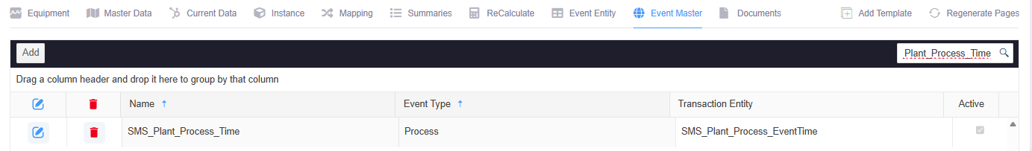

2.3 Event Configuration Entity
The Event Configuration Entity defines Attributes, Tag Mapping, and the ordered chain of States for this event.
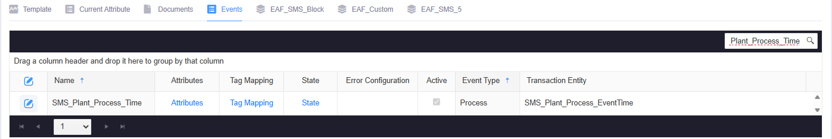

2.4 Event Configuration Tags
Attribute | Tag Name
SMSLRFPOFF | LRF_ACTUAL_POWER_OFF_TIME_MIN_PRM
SMSCCMTotalBillets | CCM_TOTAL_BILLET_COUNT_PRM
SMSCCMTurretControlOff | CCM_TURRET_CONTROL_OFF_STATUS
SMSEAFRoof | EAF_ROOF_CLOSED_STATUS
SMSCCMArm1InstantWieght | CCM_ARM_1_INSTANT_WEIGHT_TON_PRM
SMSEAFHeatsec | EAF_HEAT_TIME_SEC_PRM
SMSEAFHeatID | EAF_HEAT_NUMBER_PRM
SMSEAFActivePower | EAF_TOTAL_ENERGY_MW_PRM
SMSLRFPowerOnTime | LRF_ACTUAL_POWER_ON_TIME_MIN_PRM
SMSLRFRoofE3 | LRF_ROOF_UP_E3_STATUS
SMSEAFPowerONmin | EAF_POWER_ON_TIME_MIN_PRM
SMSEAFPowerONsec | EAF_POWER_ON_TIME_SEC_PRM
SMSEAFEBT | EAF_EBT_OPEN_STATUS
SMSLRFArcTime | LRF_ACTUAL_ARC_TIME_SEC_PRM
SMSCCMHeatID | CCM_HEAT_NUMBER_PRM
SMSLiquidMatelSteel | EAF_LIQUID_METAL_WEIGHT_TON_PRM
SMSCCMTurretLubrication | CCM_TURRET_LUBE_RUNNING_STATUS
SMSCCMArm1castPosition | CCM_ARM_1_CAST_POSITION_STATUS
SMSLRFLadleCar | LRF_LADLE_CAR_TREATMENT_POSITION_STATUS
SMSEAFHeatmin | EAF_HEAT_TIME_MIN_PRM
SMSLRFRoofE1 | LRF_ROOF_UP_E1_STATUS
SMSEAFLadleCar | EAF_LADLE_CAR_TAPPING_POSITION_STATUS
SMSEAFTapping | EAF_TAPPING_STATUS
SMSCCMArm2castPosition | CCM_ARM_2_CAST_POSITION_STATUS
SMSCCMArm2InstantWieght | CCM_ARM_2_INSTANT_WEIGHT_TON_PRM

3. Data Insert Condition - Process States
Each state below is documented in the same structure: the screenshot of its configuration, its Event Status Configuration summary, the exact state condition together with its TRUE / FALSE / NULL transition logic, and the operational meaning of every tag input used in that condition. Casting-arm-specific states (10, 11, 12, 13) are configured once per arm (Arm 1 and Arm 2); both variants are documented. States 15–17 are not used.

State 1 - EAF Roof Open for Fill Bucket Charging
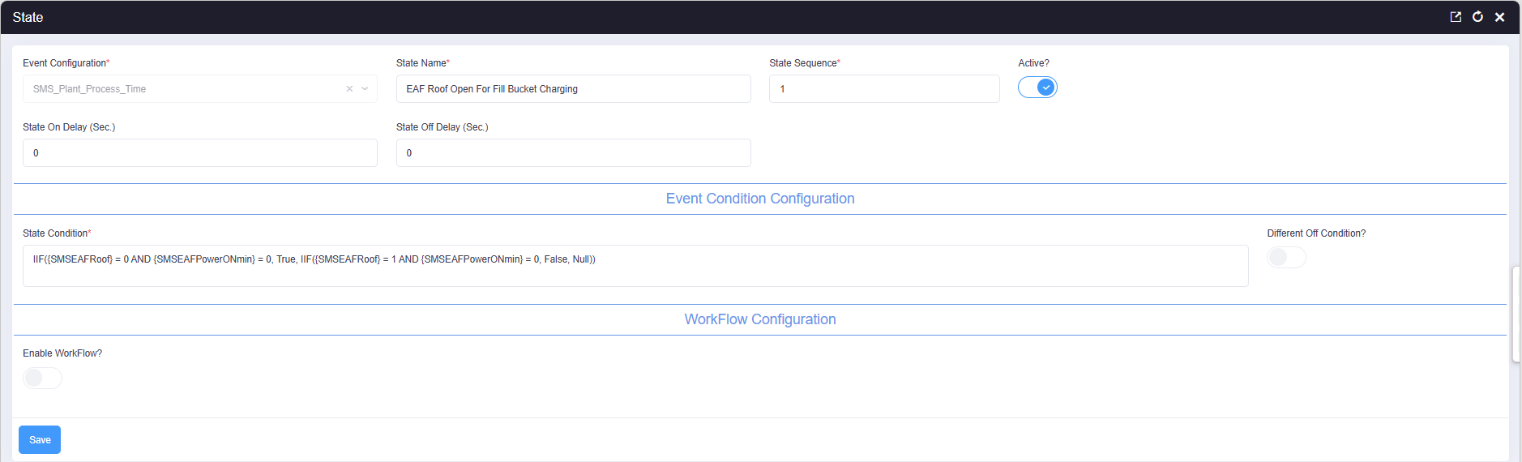

1.1 Event Status Configuration
Event status name | EAF Roof Open For Fill Bucket Charging
State sequence | 1
Active | Yes
State-On delay | 0 seconds
State-Off delay | 0 seconds
Workflow enabled | No
Workflow type | -
State-On workflow | -
State-Off workflow | -

1.2 State Condition and Transition Logic
IIF({SMSEAFRoof} = 0 AND {SMSEAFPowerONmin} = 0, True, IIF({SMSEAFRoof} = 1 AND {SMSEAFPowerONmin} = 0, False, Null))

Result | Condition evaluated | State action | Workflow
TRUE | SMSEAFRoof = 0; SMSEAFPowerONmin = 0 | Turn the event state ON | No workflow (live tag read)
FALSE | SMSEAFRoof = 1; SMSEAFPowerONmin = 0 | Turn the event state OFF | No workflow (live tag read)
NULL | Neither ON nor OFF condition is satisfied | No explicit transition for this evaluation | No workflow selected

1.3 Meaning of the Condition Inputs
Input | Value used | Operational meaning in this configuration
SMSEAFRoof | 0 | EAF roof is open, ready for scrap/fill-bucket charging; this participates in the State-On condition.
SMSEAFRoof | 1 | EAF roof is closed; this participates in the State-Off condition.
SMSEAFPowerONmin | 0 | No accumulated power-on time - confirms the furnace is currently stopped, not mid-heat.

State 2 - EAF Power On
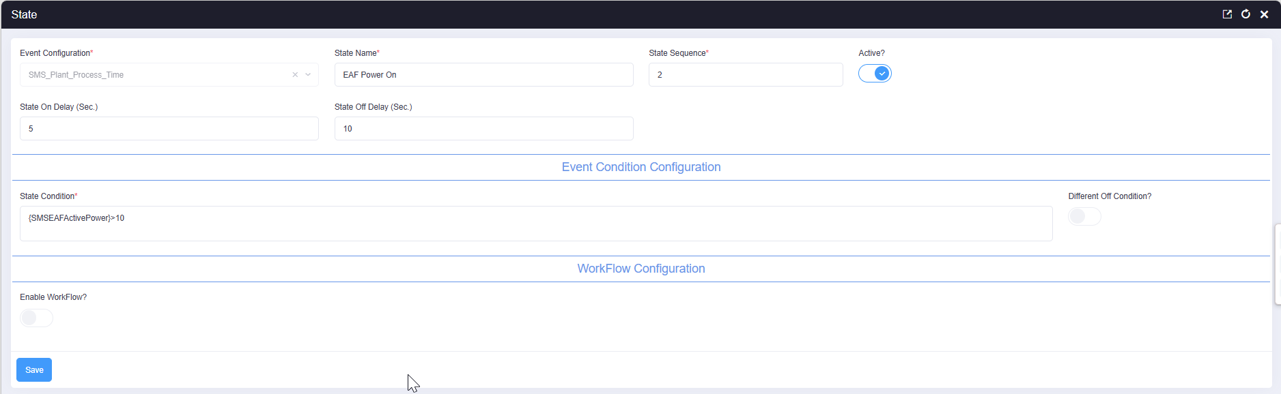

2.1 Event Status Configuration
Event status name | EAF Power On
State sequence | 2
Active | Yes
State-On delay | 5 seconds
State-Off delay | 10 seconds
Workflow enabled | No
Workflow type | -
State-On workflow | -
State-Off workflow | -

2.2 State Condition and Transition Logic
{SMSEAFActivePower} > 10

Result | Condition evaluated | State action | Workflow
TRUE | SMSEAFActivePower > 10 | Turn the event state ON | No workflow (live tag read)
FALSE | SMSEAFActivePower <= 10 | Turn the event state OFF | No workflow (live tag read)
NULL | Not applicable - this state uses a direct boolean expression, not a nested IIF | - | -

2.3 Meaning of the Condition Inputs
Input | Value used | Operational meaning in this configuration
SMSEAFActivePower | > 10 | EAF active power exceeds 10 MW, confirming the furnace is actively melting rather than idling. The 5s on-delay and 10s off-delay filter out momentary power fluctuations.

State 3 - Ladle Car At EAF
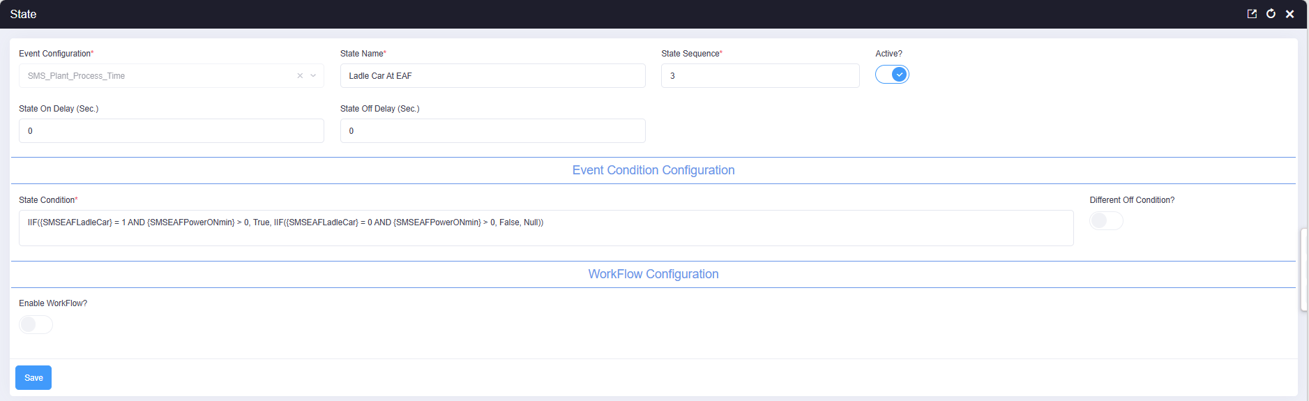

3.1 Event Status Configuration
Event status name | Ladle Car At EAF
State sequence | 3
Active | Yes
State-On delay | 0 seconds
State-Off delay | 0 seconds
Workflow enabled | No
Workflow type | -
State-On workflow | -
State-Off workflow | -

3.2 State Condition and Transition Logic
IIF({SMSEAFLadleCar} = 1 AND {SMSEAFPowerONmin} > 0, True, IIF({SMSEAFLadleCar} = 0 AND {SMSEAFPowerONmin} > 0, False, Null))

Result | Condition evaluated | State action | Workflow
TRUE | SMSEAFLadleCar = 1; SMSEAFPowerONmin > 0 | Turn the event state ON | No workflow (live tag read)
FALSE | SMSEAFLadleCar = 0; SMSEAFPowerONmin > 0 | Turn the event state OFF | No workflow (live tag read)
NULL | Neither ON nor OFF condition is satisfied | No explicit transition for this evaluation | No workflow selected

3.3 Meaning of the Condition Inputs
Input | Value used | Operational meaning in this configuration
SMSEAFLadleCar | 1 | Ladle car is in position at the EAF tapping point; participates in the State-On condition.
SMSEAFLadleCar | 0 | Ladle car has left the EAF tapping point; participates in the State-Off condition.
SMSEAFPowerONmin | > 0 | The furnace has accumulated power-on time, confirming an active melt is underway.

State 4 - EAF Tapping
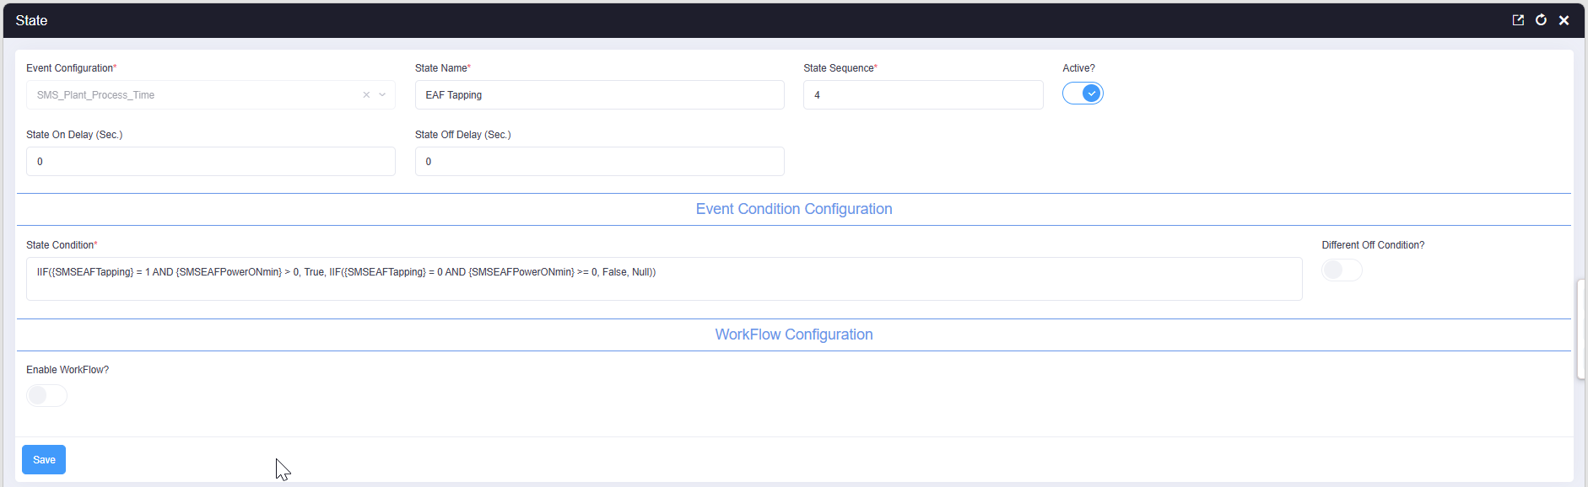

4.1 Event Status Configuration
Event status name | EAF Tapping
State sequence | 4
Active | Yes
State-On delay | 0 seconds
State-Off delay | 0 seconds
Workflow enabled | No
Workflow type | -
State-On workflow | -
State-Off workflow | -

4.2 State Condition and Transition Logic
IIF({SMSEAFTapping} = 1 AND {SMSEAFPowerONmin} > 0, True, IIF({SMSEAFTapping} = 0 AND {SMSEAFPowerONmin} >= 0, False, Null))

Result | Condition evaluated | State action | Workflow
TRUE | SMSEAFTapping = 1; SMSEAFPowerONmin > 0 | Turn the event state ON | No workflow (live tag read)
FALSE | SMSEAFTapping = 0; SMSEAFPowerONmin >= 0 | Turn the event state OFF | No workflow (live tag read)
NULL | Neither ON nor OFF condition is satisfied | No explicit transition for this evaluation | No workflow selected

4.3 Meaning of the Condition Inputs
Input | Value used | Operational meaning in this configuration
SMSEAFTapping | 1 | Tapping is in progress - liquid steel is being poured from the furnace into the ladle.
SMSEAFTapping | 0 | Tapping has ended.
SMSEAFPowerONmin | > 0 / >= 0 | Confirms power-on time is present (TRUE) or at least non-negative (FALSE), tying tapping to the active heat.

State 5 - Ladle Car Move from EAF To LRF
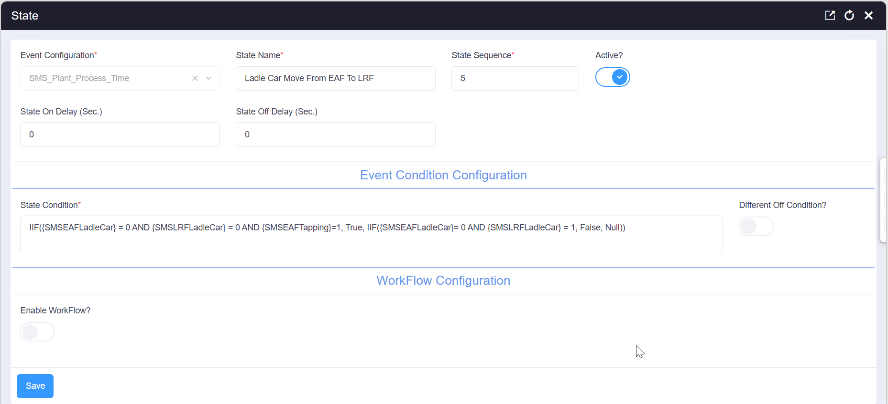

5.1 Event Status Configuration
Event status name | Ladle Car Move From EAF To LRF
State sequence | 5
Active | Yes
State-On delay | 0 seconds
State-Off delay | 0 seconds
Workflow enabled | No
Workflow type | -
State-On workflow | -
State-Off workflow | -

5.2 State Condition and Transition Logic
IIF({SMSEAFLadleCar} = 0 AND {SMSLRFLadleCar} = 0 AND {SMSEAFTapping}=1, True, IIF({SMSEAFLadleCar}= 0 AND {SMSLRFLadleCar} = 1, False, Null))

Result | Condition evaluated | State action | Workflow
TRUE | SMSEAFLadleCar = 0; SMSLRFLadleCar = 0; SMSEAFTapping = 1 | Turn the event state ON | No workflow (live tag read)
FALSE | SMSEAFLadleCar = 0; SMSLRFLadleCar = 1 | Turn the event state OFF | No workflow (live tag read)
NULL | Neither ON nor OFF condition is satisfied | No explicit transition for this evaluation | No workflow selected

5.3 Meaning of the Condition Inputs
Input | Value used | Operational meaning in this configuration
SMSEAFLadleCar | 0 | Ladle car has left the EAF position - required for both the ON and OFF branches.
SMSLRFLadleCar | 0 | Ladle car has not yet reached the LRF position; participates in the State-On condition.
SMSLRFLadleCar | 1 | Ladle car has reached the LRF position; participates in the State-Off condition.
SMSEAFTapping | 1 | Tapping had occurred, confirming the ladle now in transit actually received liquid steel from this heat.

State 6 - Ladle Car Reach At LRF
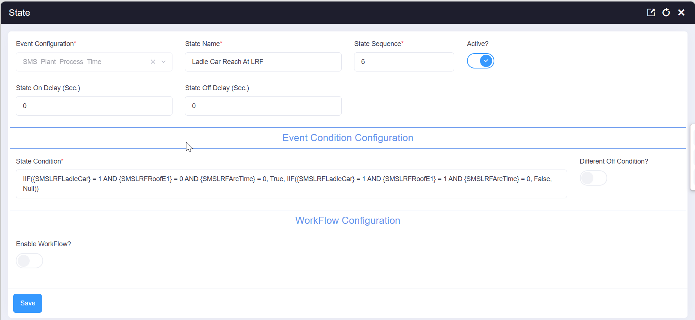

6.1 Event Status Configuration
Event status name | Ladle Car Reach At LRF
State sequence | 6
Active | Yes
State-On delay | 0 seconds
State-Off delay | 0 seconds
Workflow enabled | No
Workflow type | -
State-On workflow | -
State-Off workflow | -

6.2 State Condition and Transition Logic
IIF({SMSLRFLadleCar} = 1 AND {SMSLRFRoofE1} = 0 AND {SMSLRFArcTime} = 0, True, IIF({SMSLRFLadleCar} = 1 AND {SMSLRFRoofE1} = 1 AND {SMSLRFArcTime} = 0, False, Null))

Result | Condition evaluated | State action | Workflow
TRUE | SMSLRFLadleCar = 1; SMSLRFRoofE1 = 0; SMSLRFArcTime = 0 | Turn the event state ON | No workflow (live tag read)
FALSE | SMSLRFLadleCar = 1; SMSLRFRoofE1 = 1; SMSLRFArcTime = 0 | Turn the event state OFF | No workflow (live tag read)
NULL | Neither ON nor OFF condition is satisfied | No explicit transition for this evaluation | No workflow selected

6.3 Meaning of the Condition Inputs
Input | Value used | Operational meaning in this configuration
SMSLRFLadleCar | 1 | Ladle car is at the LRF position - required for both branches.
SMSLRFRoofE1 | 0 | LRF roof is still open (not yet lowered for treatment); participates in the State-On condition.
SMSLRFRoofE1 | 1 | LRF roof has closed; participates in the State-Off condition, marking the end of this waiting state.
SMSLRFArcTime | 0 | No arc time yet recorded - treatment has not started.

State 7 - LRF Roof Close
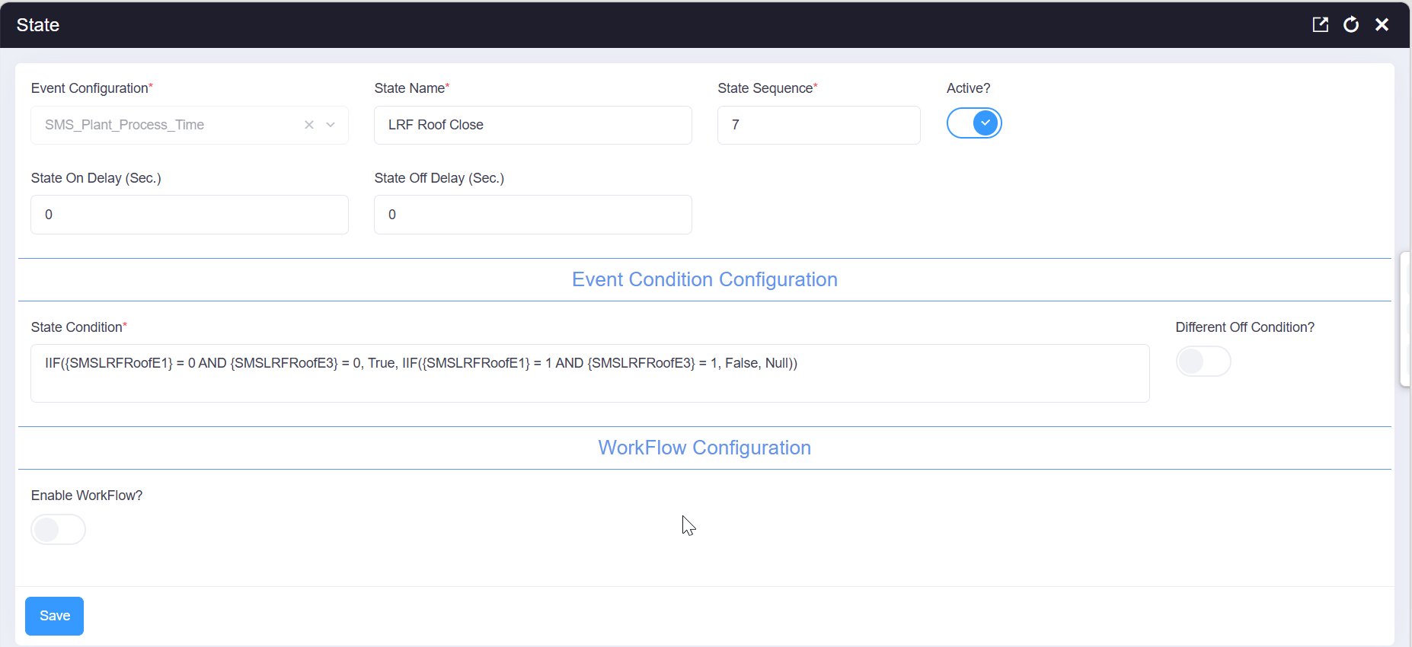

7.1 Event Status Configuration
Event status name | LRF Roof Close
State sequence | 7
Active | Yes
State-On delay | 0 seconds
State-Off delay | 0 seconds
Workflow enabled | No
Workflow type | -
State-On workflow | -
State-Off workflow | -

7.2 State Condition and Transition Logic
IIF({SMSLRFRoofE1} = 0 AND {SMSLRFRoofE3} = 0, True, IIF({SMSLRFRoofE1} = 1 AND {SMSLRFRoofE3} = 1, False, Null))

Result | Condition evaluated | State action | Workflow
TRUE | SMSLRFRoofE1 = 0; SMSLRFRoofE3 = 0 | Turn the event state ON | No workflow (live tag read)
FALSE | SMSLRFRoofE1 = 1; SMSLRFRoofE3 = 1 | Turn the event state OFF | No workflow (live tag read)
NULL | Neither ON nor OFF condition is satisfied | No explicit transition for this evaluation | No workflow selected

7.3 Meaning of the Condition Inputs
Input | Value used | Operational meaning in this configuration
SMSLRFRoofE1 | 0 / 1 | LRF roof position indicator E1: 0 = down/closed, 1 = up/open.
SMSLRFRoofE3 | 0 / 1 | LRF roof position indicator E3: 0 = down/closed, 1 = up/open. Both indicators must agree to confirm roof position.

State 8 - LRF Arcing
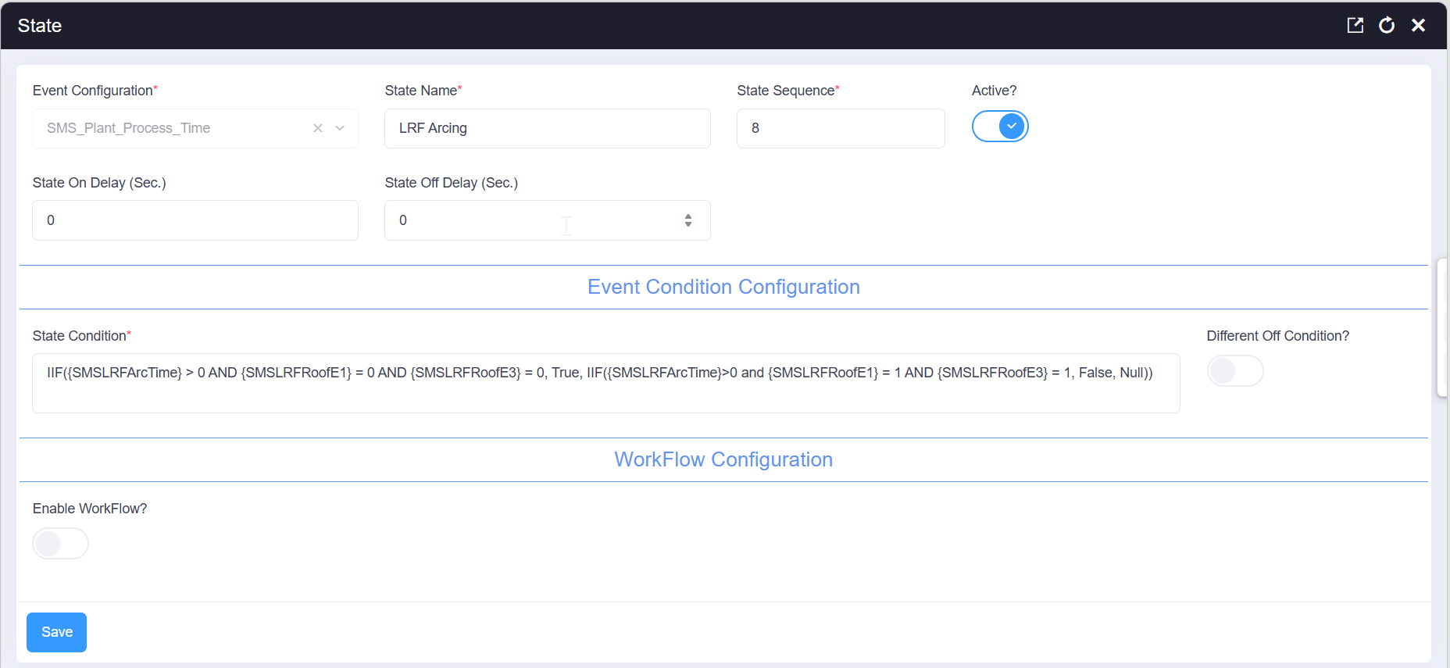

8.1 Event Status Configuration
Event status name | LRF Arcing
State sequence | 8
Active | Yes
State-On delay | 0 seconds
State-Off delay | 0 seconds
Workflow enabled | No
Workflow type | -
State-On workflow | -
State-Off workflow | -

8.2 State Condition and Transition Logic
IIF({SMSLRFArcTime} > 0 AND {SMSLRFRoofE1} = 0 AND {SMSLRFRoofE3} = 0, True, IIF({SMSLRFArcTime}>0 and {SMSLRFRoofE1} = 1 AND {SMSLRFRoofE3} = 1, False, Null))

Result | Condition evaluated | State action | Workflow
TRUE | SMSLRFArcTime > 0; SMSLRFRoofE1 = 0; SMSLRFRoofE3 = 0 | Turn the event state ON | No workflow (live tag read)
FALSE | SMSLRFArcTime > 0; SMSLRFRoofE1 = 1; SMSLRFRoofE3 = 1 | Turn the event state OFF | No workflow (live tag read)
NULL | Neither ON nor OFF condition is satisfied | No explicit transition for this evaluation | No workflow selected

8.3 Meaning of the Condition Inputs
Input | Value used | Operational meaning in this configuration
SMSLRFArcTime | > 0 | Arc time is accumulating - required for both branches, confirming arcing has started.
SMSLRFRoofE1 | 0 / 1 | Roof closed (0) during active arcing; roof open (1) once arcing has finished.
SMSLRFRoofE3 | 0 / 1 | Second roof indicator, must agree with E1.

State 9 - LRF Roof Open
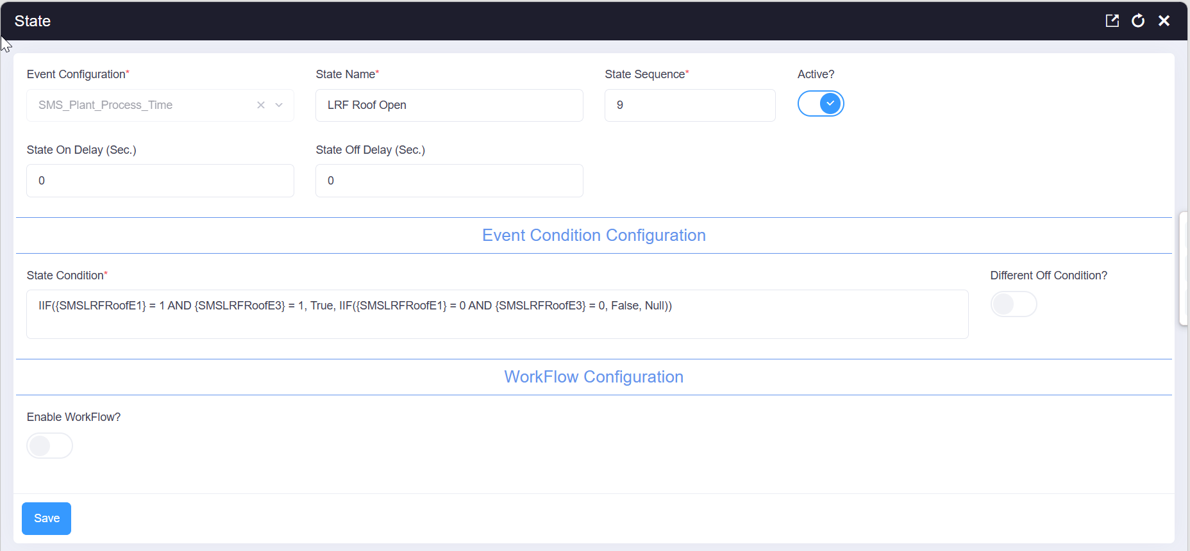

9.1 Event Status Configuration
Event status name | LRF Roof Open
State sequence | 9
Active | Yes
State-On delay | 0 seconds
State-Off delay | 0 seconds
Workflow enabled | No
Workflow type | -
State-On workflow | -
State-Off workflow | -

9.2 State Condition and Transition Logic
IIF({SMSLRFRoofE1} = 1 AND {SMSLRFRoofE3} = 1, True, IIF({SMSLRFRoofE1} = 0 AND {SMSLRFRoofE3} = 0, False, Null))

Result | Condition evaluated | State action | Workflow
TRUE | SMSLRFRoofE1 = 1; SMSLRFRoofE3 = 1 | Turn the event state ON | No workflow (live tag read)
FALSE | SMSLRFRoofE1 = 0; SMSLRFRoofE3 = 0 | Turn the event state OFF | No workflow (live tag read)
NULL | Neither ON nor OFF condition is satisfied | No explicit transition for this evaluation | No workflow selected

9.3 Meaning of the Condition Inputs
Input | Value used | Operational meaning in this configuration
SMSLRFRoofE1 | 0 / 1 | LRF roof position indicator E1 - the mirror image of state 7.
SMSLRFRoofE3 | 0 / 1 | LRF roof position indicator E3, must agree with E1.

State 10 (Arm 1) - Ladle Move from LRF To CCM
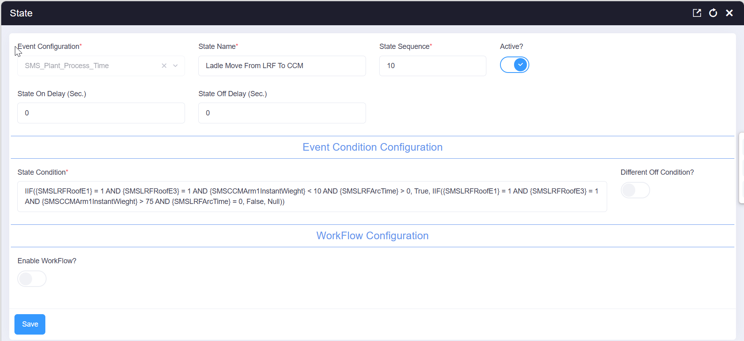

10 (Arm 1).1 Event Status Configuration
Event status name | Ladle Move From LRF To CCM
State sequence | 10
Active | Yes
State-On delay | 0 seconds
State-Off delay | 0 seconds
Workflow enabled | No
Workflow type | -
State-On workflow | -
State-Off workflow | -

10 (Arm 1).2 State Condition and Transition Logic
IIF({SMSLRFRoofE1} = 1 AND {SMSLRFRoofE3} = 1 AND {SMSCCMArm1InstantWieght} < 10 AND {SMSLRFArcTime} > 0, True, IIF({SMSLRFRoofE1} = 1 AND {SMSLRFRoofE3} = 1 AND {SMSCCMArm1InstantWieght} > 75 AND {SMSLRFArcTime} = 0, False, Null))

Result | Condition evaluated | State action | Workflow
TRUE | SMSLRFRoofE1 = 1; SMSLRFRoofE3 = 1; SMSCCMArm1InstantWieght < 10; SMSLRFArcTime > 0 | Turn the event state ON | No workflow (live tag read)
FALSE | SMSLRFRoofE1 = 1; SMSLRFRoofE3 = 1; SMSCCMArm1InstantWieght > 75; SMSLRFArcTime = 0 | Turn the event state OFF | No workflow (live tag read)
NULL | Neither ON nor OFF condition is satisfied | No explicit transition for this evaluation | No workflow selected

10 (Arm 1).3 Meaning of the Condition Inputs
Input | Value used | Operational meaning in this configuration
SMSLRFRoofE1 / E3 | 1 | LRF roof is open, confirming treatment has finished and the ladle is ready to move.
SMSCCMArm1InstantWieght | < 10 | Arm 1 ladle weight is still low - the ladle has not yet arrived at CCM.
SMSCCMArm1InstantWieght | > 75 | Arm 1 ladle weight has reached a full ladle - arrival is complete, ending this transit state.
SMSLRFArcTime | > 0 / = 0 | Confirms arcing occurred (ON) or has been reset for the new heat (OFF).

State 10 (Arm 2) - Ladle Move from LRF To CCM
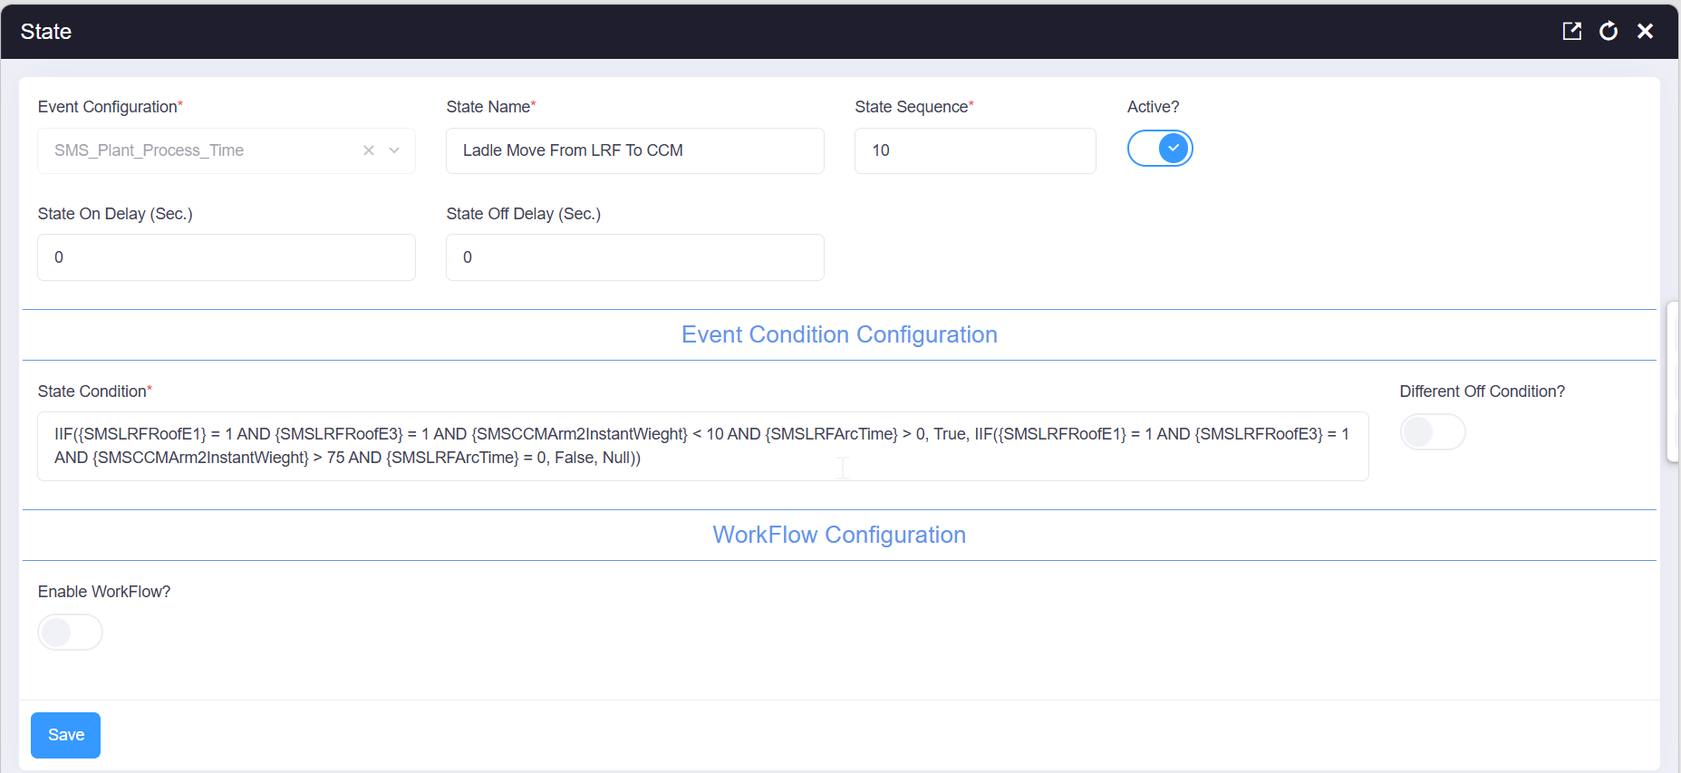

10 (Arm 2).1 Event Status Configuration
Event status name | Ladle Move From LRF To CCM
State sequence | 10
Active | Yes
State-On delay | 0 seconds
State-Off delay | 0 seconds
Workflow enabled | No
Workflow type | -
State-On workflow | -
State-Off workflow | -

10 (Arm 2).2 State Condition and Transition Logic
IIF({SMSLRFRoofE1} = 1 AND {SMSLRFRoofE3} = 1 AND {SMSCCMArm2InstantWieght} < 10 AND {SMSLRFArcTime} > 0, True, IIF({SMSLRFRoofE1} = 1 AND {SMSLRFRoofE3} = 1 AND {SMSCCMArm2InstantWieght} > 75 AND {SMSLRFArcTime} = 0, False, Null))

Result | Condition evaluated | State action | Workflow
TRUE | SMSLRFRoofE1 = 1; SMSLRFRoofE3 = 1; SMSCCMArm2InstantWieght < 10; SMSLRFArcTime > 0 | Turn the event state ON | No workflow (live tag read)
FALSE | SMSLRFRoofE1 = 1; SMSLRFRoofE3 = 1; SMSCCMArm2InstantWieght > 75; SMSLRFArcTime = 0 | Turn the event state OFF | No workflow (live tag read)
NULL | Neither ON nor OFF condition is satisfied | No explicit transition for this evaluation | No workflow selected

10 (Arm 2).3 Meaning of the Condition Inputs
Input | Value used | Operational meaning in this configuration
SMSLRFRoofE1 / E3 | 1 | LRF roof is open, confirming treatment has finished and the ladle is ready to move.
SMSCCMArm2InstantWieght | < 10 | Arm 2 ladle weight is still low - the ladle has not yet arrived at CCM.
SMSCCMArm2InstantWieght | > 75 | Arm 2 ladle weight has reached a full ladle - arrival is complete, ending this transit state.
SMSLRFArcTime | > 0 / = 0 | Confirms arcing occurred (ON) or has been reset for the new heat (OFF).

State 11 (Arm 1) - Ladle At CCM Arm 1 Rest Position
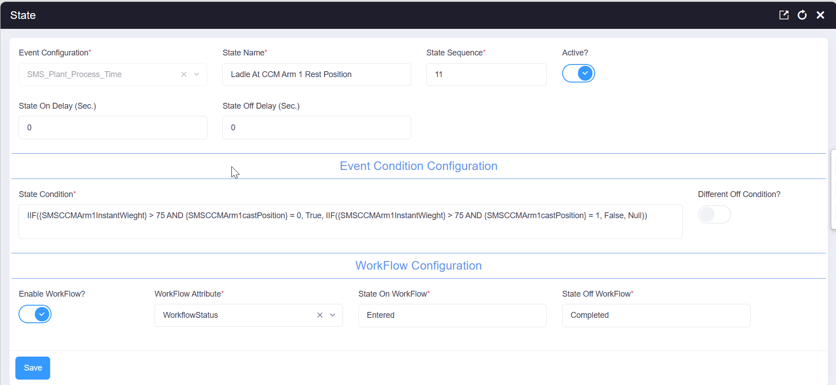

11 (Arm 1).1 Event Status Configuration
Event status name | Ladle At CCM Arm 1 Rest Position
State sequence | 11
Active | Yes
State-On delay | 0 seconds
State-Off delay | 0 seconds
Workflow enabled | Yes
Workflow type | Workflow
State-On workflow | Entered
State-Off workflow | Completed

11 (Arm 1).2 State Condition and Transition Logic
IIF({SMSCCMArm1InstantWieght} > 75 AND {SMSCCMArm1castPosition} = 0, True, IIF({SMSCCMArm1InstantWieght} > 75 AND {SMSCCMArm1castPosition} = 1, False, Null))

Result | Condition evaluated | State action | Workflow
TRUE | SMSCCMArm1InstantWieght > 75; SMSCCMArm1castPosition = 0 | Turn the event state ON | Entered
FALSE | SMSCCMArm1InstantWieght > 75; SMSCCMArm1castPosition = 1 | Turn the event state OFF | Completed
NULL | Neither ON nor OFF condition is satisfied | No explicit transition for this evaluation | No workflow selected

11 (Arm 1).3 Meaning of the Condition Inputs
Input | Value used | Operational meaning in this configuration
SMSCCMArm1InstantWieght | > 75 | A full ladle (over 75 tons) is present on Arm 1 - required for both branches.
SMSCCMArm1castPosition | 0 | Arm 1 is still in its rest position, before casting; participates in the State-On (Entered) condition.
SMSCCMArm1castPosition | 1 | Arm 1 has rotated into the casting position; participates in the State-Off (Completed) condition.

State 11 (Arm 2) - Ladle At CCM Arm 2 Rest Position
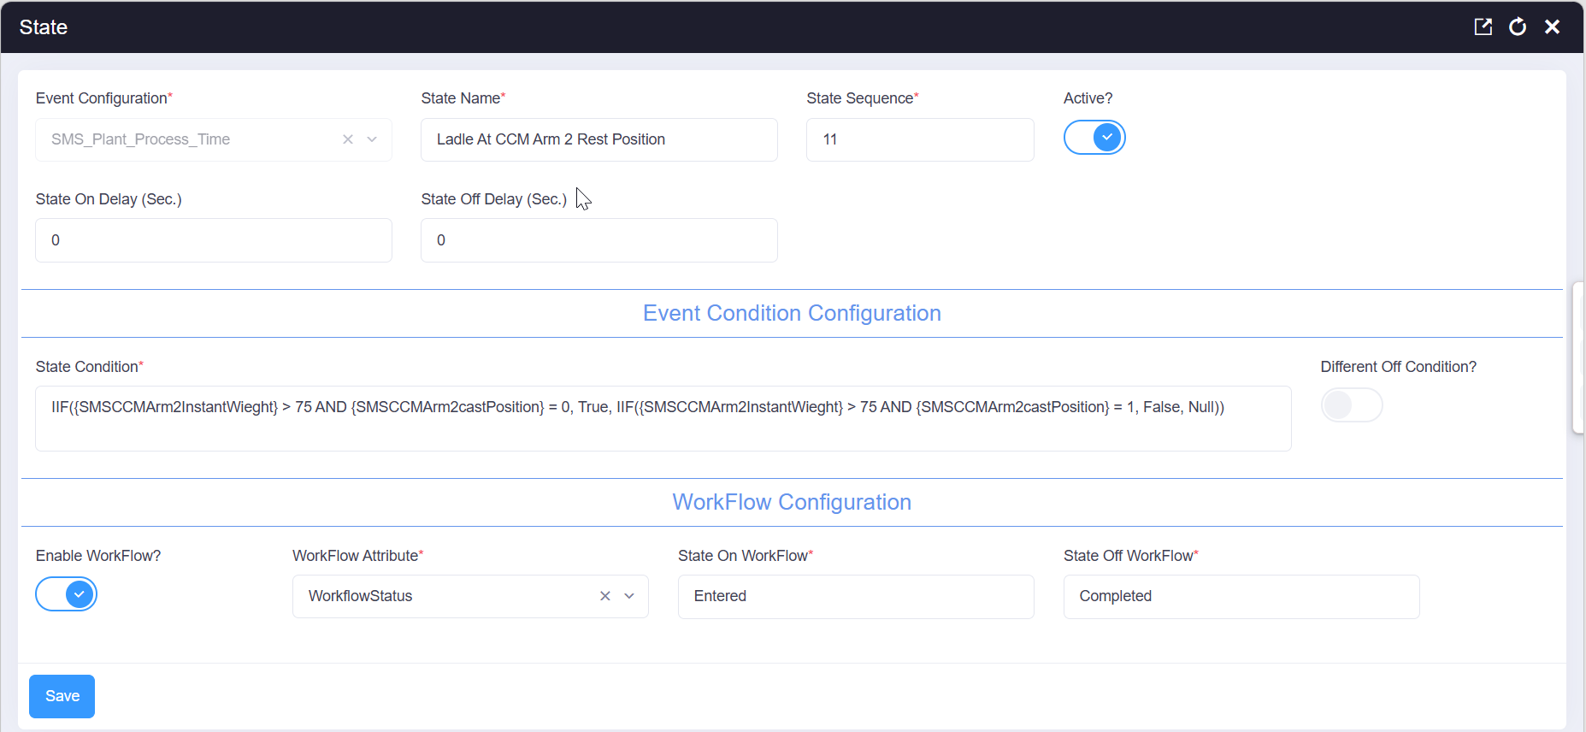

11 (Arm 2).1 Event Status Configuration
Event status name | Ladle At CCM Arm 2 Rest Position
State sequence | 11
Active | Yes
State-On delay | 0 seconds
State-Off delay | 0 seconds
Workflow enabled | Yes
Workflow type | Workflow
State-On workflow | Entered
State-Off workflow | Completed

11 (Arm 2).2 State Condition and Transition Logic
IIF({SMSCCMArm2InstantWieght} > 75 AND {SMSCCMArm2castPosition} = 0, True, IIF({SMSCCMArm2InstantWieght} > 75 AND {SMSCCMArm2castPosition} = 1, False, Null))

Result | Condition evaluated | State action | Workflow
TRUE | SMSCCMArm2InstantWieght > 75; SMSCCMArm2castPosition = 0 | Turn the event state ON | Entered
FALSE | SMSCCMArm2InstantWieght > 75; SMSCCMArm2castPosition = 1 | Turn the event state OFF | Completed
NULL | Neither ON nor OFF condition is satisfied | No explicit transition for this evaluation | No workflow selected

11 (Arm 2).3 Meaning of the Condition Inputs
Input | Value used | Operational meaning in this configuration
SMSCCMArm2InstantWieght | > 75 | A full ladle (over 75 tons) is present on Arm 2 - required for both branches.
SMSCCMArm2castPosition | 0 | Arm 2 is still in its rest position, before casting; participates in the State-On (Entered) condition.
SMSCCMArm2castPosition | 1 | Arm 2 has rotated into the casting position; participates in the State-Off (Completed) condition.

State 12 (Arm 1) - Turret Rotation
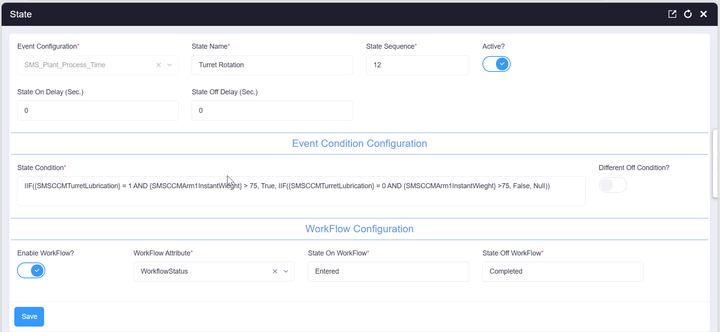

12 (Arm 1).1 Event Status Configuration
Event status name | Turret Rotation
State sequence | 12
Active | Yes
State-On delay | 0 seconds
State-Off delay | 0 seconds
Workflow enabled | Yes
Workflow type | Workflow
State-On workflow | Entered
State-Off workflow | Completed

12 (Arm 1).2 State Condition and Transition Logic
IIF({SMSCCMTurretLubrication} = 1 AND {SMSCCMArm1InstantWieght} > 75, True, IIF({SMSCCMTurretLubrication} = 0 AND {SMSCCMArm1InstantWieght} >75, False, Null))

Result | Condition evaluated | State action | Workflow
TRUE | SMSCCMTurretLubrication = 1; SMSCCMArm1InstantWieght > 75 | Turn the event state ON | Entered
FALSE | SMSCCMTurretLubrication = 0; SMSCCMArm1InstantWieght > 75 | Turn the event state OFF | Completed
NULL | Neither ON nor OFF condition is satisfied | No explicit transition for this evaluation | No workflow selected

12 (Arm 1).3 Meaning of the Condition Inputs
Input | Value used | Operational meaning in this configuration
SMSCCMTurretLubrication | 1 | Turret lubrication is running, indicating the turret is actively rotating; participates in the State-On (Entered) condition.
SMSCCMTurretLubrication | 0 | Turret lubrication has stopped, indicating rotation has finished; participates in the State-Off (Completed) condition.
SMSCCMArm1InstantWieght | > 75 | Confirms a full ladle is being rotated on Arm 1 - required for both branches.

State 12 (Arm 2) — Turret Rotation
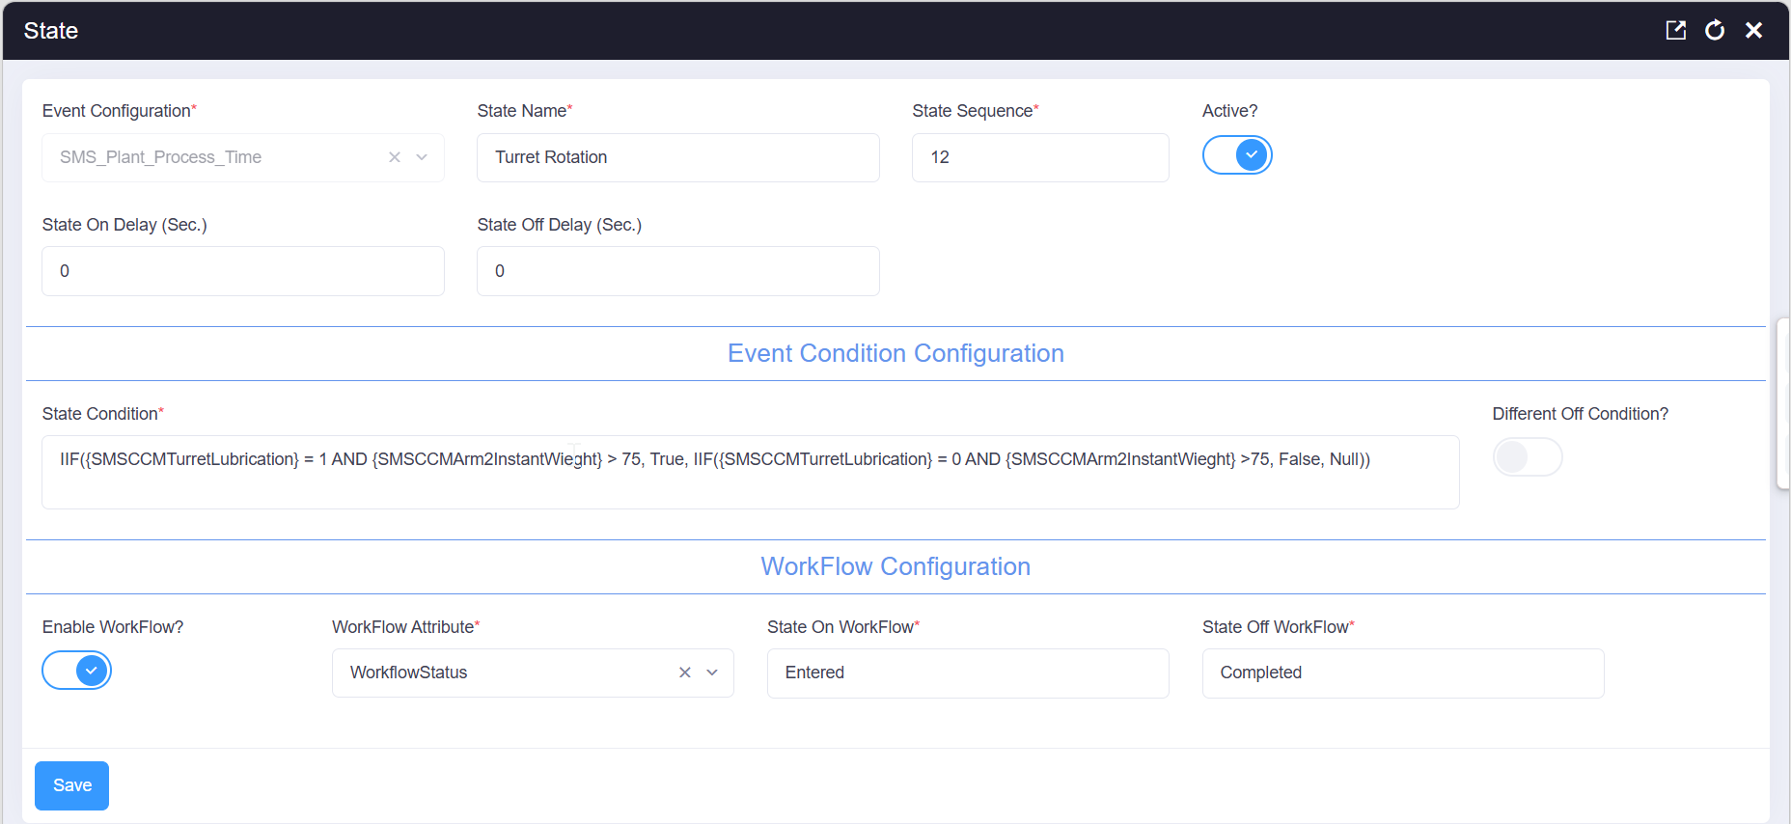

12 (Arm 2).1 Event Status Configuration
Event status name | Turret Rotation
State sequence | 12
Active | Yes
State-On delay | 0 seconds
State-Off delay | 0 seconds
Workflow enabled | Yes
Workflow type | Workflow
State-On workflow | Entered
State-Off workflow | Completed

12 (Arm 2).2 State Condition and Transition Logic
IIF({SMSCCMTurretLubrication} = 1 AND {SMSCCMArm2InstantWieght} > 75, True, IIF({SMSCCMTurretLubrication} = 0 AND {SMSCCMArm2InstantWieght} >75, False, Null))

Result | Condition evaluated | State action | Workflow
TRUE | SMSCCMTurretLubrication = 1; SMSCCMArm2InstantWieght > 75 | Turn the event state ON | Entered
FALSE | SMSCCMTurretLubrication = 0; SMSCCMArm2InstantWieght > 75 | Turn the event state OFF | Completed
NULL | Neither ON nor OFF condition is satisfied | No explicit transition for this evaluation | No workflow selected

12 (Arm 2).3 Meaning of the Condition Inputs
Input | Value used | Operational meaning in this configuration
SMSCCMTurretLubrication | 1 | Turret lubrication is running, indicating the turret is actively rotating; participates in the State-On (Entered) condition.
SMSCCMTurretLubrication | 0 | Turret lubrication has stopped, indicating rotation has finished; participates in the State-Off (Completed) condition.
SMSCCMArm2InstantWieght | > 75 | Confirms a full ladle is being rotated on Arm 2 - required for both branches.

State 13 (Arm 1) — CCM Arm 1 Casting Position
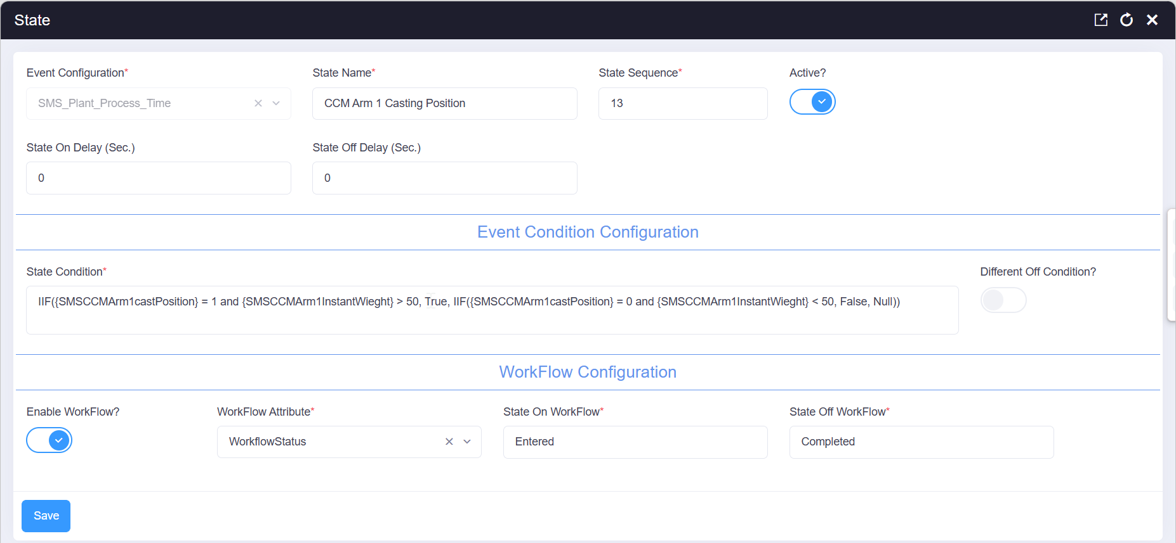

13 (Arm 1).1 Event Status Configuration
Event status name | CCM Arm 1 Casting Position
State sequence | 13
Active | Yes
State-On delay | 0 seconds
State-Off delay | 0 seconds
Workflow enabled | Yes
Workflow type | Workflow
State-On workflow | Entered
State-Off workflow | Completed

13 (Arm 1).2 State Condition and Transition Logic
IIF({SMSCCMArm1castPosition} = 1 and {SMSCCMArm1InstantWieght} > 50, True, IIF({SMSCCMArm1castPosition} = 0 and {SMSCCMArm1InstantWieght} < 50, False, Null))

Result | Condition evaluated | State action | Workflow
TRUE | SMSCCMArm1castPosition = 1; SMSCCMArm1InstantWieght > 50 | Turn the event state ON | Entered
FALSE | SMSCCMArm1castPosition = 0; SMSCCMArm1InstantWieght < 50 | Turn the event state OFF | Completed
NULL | Neither ON nor OFF condition is satisfied | No explicit transition for this evaluation | No workflow selected

13 (Arm 1).3 Meaning of the Condition Inputs
Input | Value used | Operational meaning in this configuration
SMSCCMArm1castPosition | 1 | Arm 1 is in the casting position; participates in the State-On (Entered) condition.
SMSCCMArm1castPosition | 0 | Arm 1 has left the casting position; participates in the State-Off (Completed) condition.
SMSCCMArm1InstantWieght | > 50 | Ladle still holds a significant quantity of liquid steel - casting is genuinely underway.
SMSCCMArm1InstantWieght | < 50 | Ladle weight has dropped below half - the ladle is empty or nearly empty, casting is ending.

State 13 (Arm 2) — CCM Arm 2 Casting Position
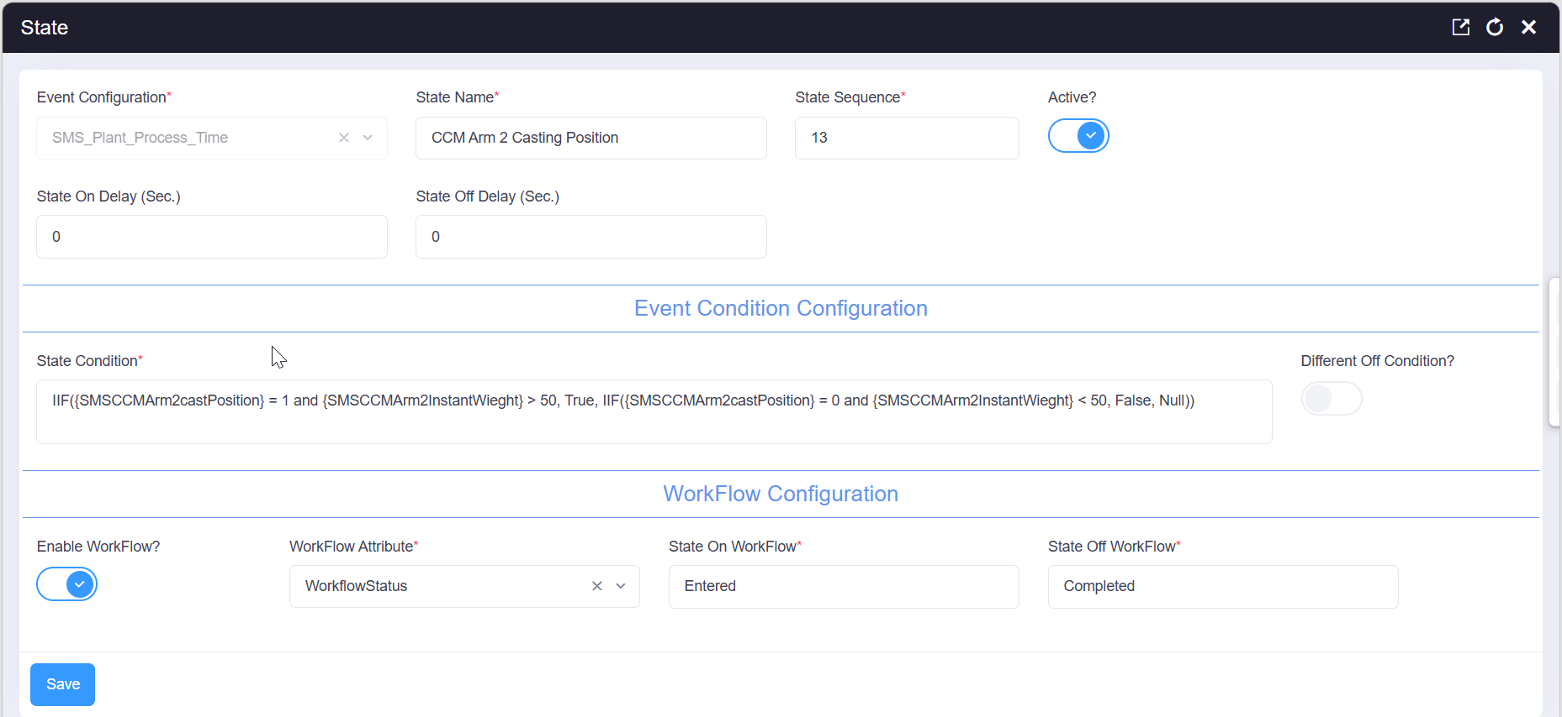

13 (Arm 2).1 Event Status Configuration
Event status name | CCM Arm 2 Casting Position
State sequence | 13
Active | Yes
State-On delay | 0 seconds
State-Off delay | 0 seconds
Workflow enabled | Yes
Workflow type | Workflow
State-On workflow | Entered
State-Off workflow | Completed

13 (Arm 2).2 State Condition and Transition Logic
IIF({SMSCCMArm2castPosition} = 1 and {SMSCCMArm2InstantWieght} > 50, True, IIF({SMSCCMArm2castPosition} = 0 and {SMSCCMArm2InstantWieght} < 50, False, Null))

Result | Condition evaluated | State action | Workflow
TRUE | SMSCCMArm2castPosition = 1; SMSCCMArm2InstantWieght > 50 | Turn the event state ON | Entered
FALSE | SMSCCMArm2castPosition = 0; SMSCCMArm2InstantWieght < 50 | Turn the event state OFF | Completed
NULL | Neither ON nor OFF condition is satisfied | No explicit transition for this evaluation | No workflow selected

13 (Arm 2).3 Meaning of the Condition Inputs
Input | Value used | Operational meaning in this configuration
SMSCCMArm2castPosition | 1 | Arm 2 is in the casting position; participates in the State-On (Entered) condition.
SMSCCMArm2castPosition | 0 | Arm 2 has left the casting position; participates in the State-Off (Completed) condition.
SMSCCMArm2InstantWieght | > 50 | Ladle still holds a significant quantity of liquid steel - casting is genuinely underway.
SMSCCMArm2InstantWieght | < 50 | Ladle weight has dropped below half - the ladle is empty or nearly empty, casting is ending.

State 14 - Billets Production
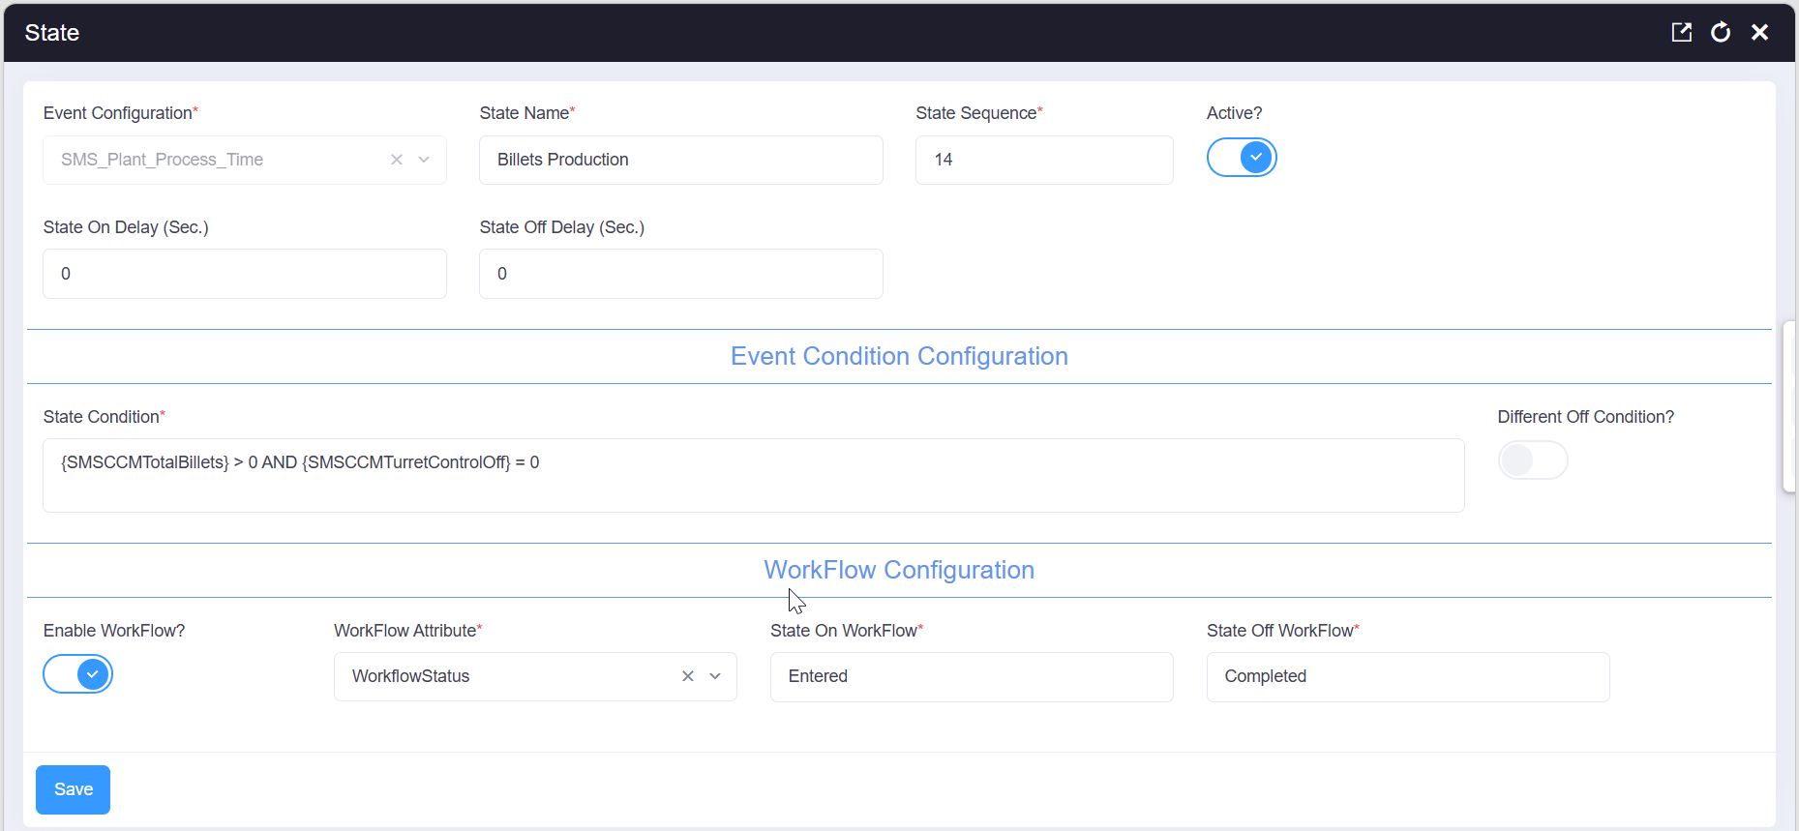

14.1 Event Status Configuration
Event status name | Billets Production
State sequence | 14
Active | Yes
State-On delay | 0 seconds
State-Off delay | 0 seconds
Workflow enabled | Yes
Workflow type | Workflow
State-On workflow | Entered
State-Off workflow | Completed

14.2 State Condition and Transition Logic
{SMSCCMTotalBillets} > 0 AND {SMSCCMTurretControlOff} = 0

Result | Condition evaluated | State action | Workflow
TRUE | SMSCCMTotalBillets > 0 AND SMSCCMTurretControlOff = 0 | Turn the event state ON | Entered
FALSE | NOT (SMSCCMTotalBillets > 0 AND SMSCCMTurretControlOff = 0) | Turn the event state OFF | Completed
NULL | Not applicable — this state uses a direct boolean expression, not a nested IIF | - | -

14.3 Meaning of the Condition Inputs
Input | Value used | Operational meaning in this configuration
SMSCCMTotalBillets | > 0 | Billets are being counted, confirming production output exists for the current cast.
SMSCCMTurretControlOff | = 0 | Turret control is still active (automatic), confirming billet counting reflects normal production rather than a manual/stopped state.

State 18 - CCM Turret Control Off
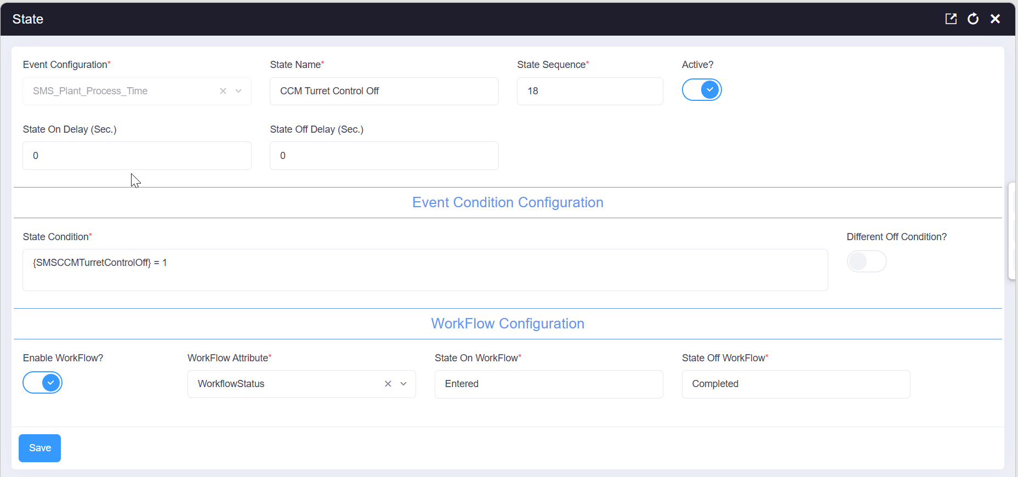

18.1 Event Status Configuration
Event status name | CCM Turret Control Off
State sequence | 18
Active | Yes
State-On delay | 0 seconds
State-Off delay | 0 seconds
Workflow enabled | Yes
Workflow type | Workflow
State-On workflow | Entered
State-Off workflow | Completed

18.2 State Condition and Transition Logic
{SMSCCMTurretControlOff} = 1

Result | Condition evaluated | State action | Workflow
TRUE | SMSCCMTurretControlOff = 1 | Turn the event state ON | Entered
FALSE | SMSCCMTurretControlOff = 0 | Turn the event state OFF | Completed
NULL | Not applicable — this state uses a direct boolean expression, not a nested IIF | - | -

18.3 Meaning of the Condition Inputs
Input | Value used | Operational meaning in this configuration
SMSCCMTurretControlOff | 1 | Turret control has been switched off - for example during manual intervention or at the end of a casting sequence.
The workflow referenced by states 11 onward is defined against the SMS_Plant_Process_EventTime entity under the name "Process Time CCM HeatNo insert" (Application: DEFAULT), as shown below.
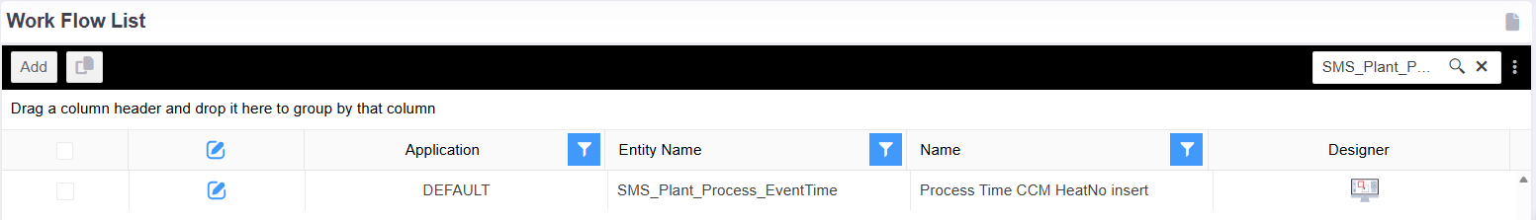

4. Workflow Entered State - Stored Procedure Action
This single action serves all of the workflow-enabled states (11 onward). It resolves the correct heat ID depending on which state triggered it - carrying the heat ID forward from LRF Roof Open for the CCM-arm states, and from the CCM rest-position states for the casting and billet-production states - decrements it by one to get the actual heat ID, and, for the CCM casting-position states, copies the liquid-metal weight from LRF_Per_Heat into CCM_Data. There is no separate Workflow Completed action for this event.

4.1 Workflow Entered SQL Action Details
1. Heat ID resolution for LRF-to-CCM and CCM-rest-position states - When the triggering @Status is 'Ladle Move From LRF To CCM', 'Ladle At CCM Arm 1 Rest Position', 'Ladle At CCM Arm 2 Rest Position', or 'Turret Rotation', @HeatID is set from the current record's HeatID if already populated; otherwise it falls back to the HeatID of the most recent 'LRF Roof Open' record with an earlier StartTime, carrying the heat identity forward through the ladle-transfer states.
2. Heat ID resolution for casting and billet-production states - When @Status is 'CCM Arm 2 Casting Position', 'CCM Arm 1 Casting Position', 'Billets Production', or 'CCM Turret Control Off', the same fallback pattern is applied, but this time referencing the most recent 'Ladle At CCM Arm 1 Rest Position' or 'Ladle At CCM Arm 2 Rest Position' record, since those states are the last to resolve the heat ID before casting begins.
3. Actual heat ID and record update - @ActualHeatID is set to @HeatID minus 1, and the current SMS_Plant_Process_EventTime record is updated with this ActualHeatID and the current modification timestamp.
4. Liquid-metal weight copy for casting states - When @Status is one of the two CCM casting-position states, the liquid-metal weight is read from LRF_Per_Heat for the resolved @ActualHeatID and written to CCM_Data.LiquidSteelWeight, so the CCM casting record reflects the correct liquid-metal quantity from the corresponding LRF treatment.
IF(@Status in ('Ladle Move From LRF To CCM','Ladle At CCM Arm 1 Rest Position','Ladle At CCM Arm 2 Rest Position','Turret Rotation'))
BEGIN

SELECT TOP 1
@HeatID = ISNULL(heatid,(
SELECT TOP 1 A.HeatID
FROM [Xstudio_xbatch].[dbo].[SMS_Plant_Process_EventTime] AS A WITH(NOLOCK)
WHERE A.[Status] IN ('LRF Roof Open') AND A.[StartTime]<b.[StartTime]
ORDER BY A.CreatedOn DESC))
FROM [SMS_Plant_Process_EventTime] b WITH(NOLOCK)
WHERE ID=@p_RecordId
ORDER BY CreatedOn DESC

END

IF(@Status IN ('CCM Arm 2 Casting Position','CCM Arm 1 Casting Position','Billets Production','CCM Turret Control Off'))
BEGIN

SELECT TOP 1 @HeatID=ISNULL(heatid,(
SELECT TOP 1 A.HeatID
FROM [Xstudio_xbatch].[dbo].[SMS_Plant_Process_EventTime] AS A WITH(NOLOCK)
WHERE A.[Status] IN ('Ladle At CCM Arm 1 Rest Position','Ladle At CCM Arm 2 Rest Position') AND A.[StartTime]<b.[StartTime] ORDER BY A.CreatedOn DESC))
FROM [SMS_Plant_Process_EventTime] b WITH(NOLOCK)
WHERE ID=@p_RecordId ORDER BY CreatedOn DESC

END

SELECT @ActualHeatID = @HeatID - 1

UPDATE [Xstudio_xbatch].[dbo].[SMS_Plant_Process_EventTime]
SET ActualHeatID = @ActualHeatID, ModifiedOn = GETDATE()
WHERE ID=@p_RecordId

IF(@Status in ('CCM Arm 2 Casting Position','CCM Arm 1 Casting Position'))
BEGIN

DECLARE @LiquidMetalWeight DECIMAL(18,4)

SELECT @LiquidMetalWeight=LiquidMetalWeight
FROM LRF_Per_Heat WITH(NOLOCK)
WHERE HeatID=@ActualHeatID

UPDATE CCM_Data SET LiquidSteelWeight=@LiquidMetalWeight

END
Note: This extract depends on variables declared or assigned elsewhere in the complete workflow procedure, including @Status, @HeatID, @ActualHeatID, and @p_RecordId. Because @HeatID is decremented by one to produce @ActualHeatID, confirm this offset is intentional and consistent with how HeatID is assigned upstream before relying on this logic elsewhere.

